DIGITAL DESIGN USING HDL LABORATORY (UE18EC206)

EXPERIMENT-5

SIMULATION AND FPGA IMPLEMENTATION OF BASIC LOGIC GATES, UNIVERSAL GATES AND FULL ADDER USING XILINX VIVADO TOOL

AIM: a) WRITE VERILOG CODE TO REALIZE ALL LOGIC GATES

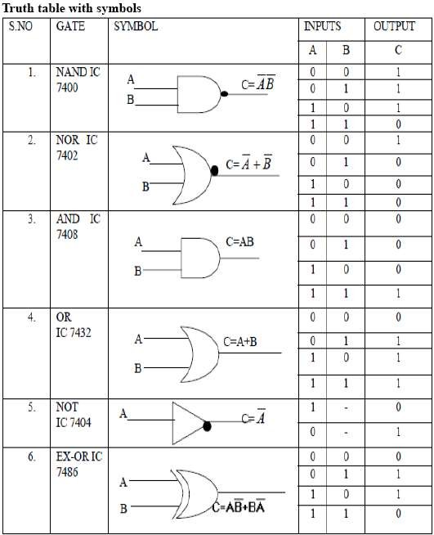

VERILOG CODE
module logic_gate ( a, b, yand,yor,ynot,ynand,ynor,yxor,yxnor );
input a,b;
output yand, yor, ynot, ynand, ynor, yxor, yxnor;
assign yand = a & b; // AND Operation
assign yor = a | b; // OR Operation
assign ynot = ~a ; // NOT Operation
assign ynand = ~(a & b); // NAND Operation
assign ynor = ~(a | b); //NOR Operation
assign yxor = a ^ b; //XOR Operation
assign yxnor =~(a^b); //XNOR Operation
endmodule // END of the module

TESTBENCH
module tb_logic_gate;
reg A,B;
wire yand, yor, ynot, ynand, ynor, yxor, yxnor;
logic_gate uut(a,b, yand, yor, ynot, ynand, ynor, yxor, yxnor);
initial
begin
A=1'b0;
B=1'b0;
#10 A=1'b0;
B=1'b1;
#10 A=1'b1;
B=1'b0;
#10 A=1'b1;
B=1'b1;
#40 $finish;
end
endmodule
SCHEMATIC

DEVICE UTILIZATION

SIMULATION RESULT

AIM: b) WRITE VERILOG CODE TO REALIZE FULL ADDER
VERILOG CODE
module Full_Adder_Structural( input A,B, Cin, output S, Cout);
wire a1, a2, a3;
xor u1(a1,A,B);
and u2(a2,A,B);
and u3(a3,a1,Cin);
or u4(Cout,a2,a3);
xor u5(S,a1,Cin);
endmodule

TESTBENCH
module Testbench_Full_Adder_Structural();
reg A,B,Cin;
wire S,Cout;

Full_Adder_Structural uut(A,B,Cin,S,Cout);
initial begin
A = 0;
B = 0;
Cin = 0;
#10;
A = 0;
B = 0;
Cin = 1;
#10;
A = 0;
B = 1;
Cin = 0;
#10;
A = 0;
B = 1;
Cin = 1;
#10;
A = 1;
B = 0;
Cin = 0;
#10;
A = 1;
B = 0;
Cin = 1;
#10;
A = 1;
B = 1;
Cin = 0;
#10;
A = 1;
B = 1;
Cin = 1;
#10;
end

endmodule
SCHEMATIC

DEVICE UTILIZATION

SIMULATION RESULT

